The Simulation Experiment of Secondary Porosity Forming Mechanism about Tuffaceous Sandstone
Header，Times New Roman，10-Point Type，Centered
Title，Times New Roman，14-Point Type，Centered,in Bold中
Liu Peipei, Northeast Petroleum University;
Zhang Yunfeng, SPE, Northeast Petroleum University
Author information，Times New Roman，10-Point Type，Centered

Abstract: The paper takes the simulation experiment on the formation mechanism of secondary pores through dissoluting the casting thin sections of rock directly. The samples are taken from the core of the tuffaceous sandstone in Nantun-Ⅰ in Beier Depression of Hailar Basin, and they are dissoluted in the conditions of 80℃, normal pressure and acetic acid of which the pH value is 6.00. Minerals’ dissolution sequence is concluded by analyzing experiment results, and the formation mechanism of secondary pores is summarized on the aspects of the way minerals corrodes and the self-factors that influence the velocity of minerals’ dissolution and so on.
Abstract，Times New Roman，10-Point Type，1.25-spaced,Justify Align
Body,
Times New Roman,10-Point Type,first line indented 0.2 in.,1.25-spaced,
Justify Align
Key word: Tuffaceous sandstone; casting slice; dissolution, secondary porosity; simulation experiment
Margin :
a. Top: 2.54 cm
b. Left : 3.18 cm
c. Right : 3.18cm
d.Bottom:2.54cm

The tuffaceous sandstone is the sands of special type that mainly contains terrigenous detrital sediment and is rich in pyroclastics (the diameter is less than 2 mm, and mass fraction lies between 5%~50%) and detrital grains of rock, interstitial materials(WANG Hong-yu, et al.,2011). The tuffaceous sandstone distributes extensively in most depositional basins at home(ZOU Cai-neng,et al.,2008), and has great exploration potential. But that this type of reservoir is mainly of low porosity and low permeability increases the difficulty of the development of oil and gas. So taking experiments on dissolution of organic acid of the tuffaceous sandstone and studying the formation mechanism of secondary pores deeply have the important guiding significance for predicting secondary porosity.
At present the researches of the rock dissolution are mostly limited to small mechanical grinding particles dissolution. The technology means as electron microscope observing, the X-ray diffraction analysis of the whole rock, energy spectrum analysis are applied to analyze the dissolution mechanism (SHI Ji-an, et al.,1994; Blake, et al., 1999; ZHAO Guo-quan, et al., 2005; Niko Kampman, et al., 2008; ZHANG Yong-wang, et al., 2009.). But the simulation experiment that summarizes the formation mechanism of secondary pores through directly dissoluting casting slice of the rock, using polarizing microscope to compare the changes before and after the dissolution of the tuffaceous sandstone is the first at home and abroad.
Taking dissolution experiment with casting slice makes the phenomena intuitive, and the secondary pores forming process can be recorded clearly. Based on the above reasons, the author takes the tuffaceous sandstone in Nantun-Ⅰ of Beier Depression as example to simulate the dissolution experiment of the casting thin sections in the conditions of 80℃, normal pressure and the organic acid of which the pH value is 6.00, and discusses the influence of the mineral composition and pore structure on the secondary pore forming.

1 Experimental methods
First-Level Headings，Times New Roman，10-Point Type，in Bold, Align Left, Paragraph Spaing(Before: 0.5pt,After:0.5pt)，Two blank spaces after number

1.1 Experimental samples and conditions
The samples are taken from the core of the sands of Bei-28 Well in Nantun-Ⅰ about Beier Depression of Hailar Basin. Based on observing the core, electron microscope scanning and analyzing the physical properties, the tuffaceous sandstone that are highly tuffaceous and develop more secondary pores are screened to make the casting thin sections without the coverslip.
Taking the acid and alkaline, water sensitivity test on the reservoir in Nantun-Ⅰ of Beier Depression, the result shows: the acid and water sensitivity degree of the reservoir are higher than the alkaline sensitivity, namely the minerals in the reservoir react with acid more easily (FENG Ya-qin,2011). In the process of burial diagenesis, the kerogen in the shale will take off the oxygen functional group between 80~120℃, and form different types of carboxylic acid anion and phenol. These organic acids have buffer action to the pH value of the formation solution and can keep it between 5~6 (Surdam R C, et al., 1989.). So the dissolution solution that the experiment uses is the common organic acid in oilfield--acetic acid, and the PH value of the solution is 6.00, conditions of temperature and pressure is 80℃, normal pressure.
Second-Level Headings，Times New Roman，10-Point Type，in Bold, Align Left, Paragraph Spaing(Before: 0.5pt,After:0pt)，Two blank spaces after number

1.2 Experimental method
Before dissolution, take pictures of the following phenomena under the polarizing microscope: intragranular dissolution pores, interparticle dissolution pores, moldic pores, calcite cementation or replacement, typical feldspar subtypes, etc.; Then in the box with the constant temperature of 80℃ and normal pressure, put casting thin sections into the acetic acid solution with the PH value of 6.00 to corrode, and observe them under microscope every 2 hours. At the same time, replace solution to keep the dissolution conditions constant, and take pictures to record corresponding parts before dissoluting. Compare the photos before and after the experiment, then analyze and discuss the experiment results.
2 Experimental results and discussion
2.1 Dissolution of carbonate minerals
The crack fillings are mainly carbonate mineral--calcite under the observation of microscope. After four hours dissoluting, the experiment results are shown in Fig.1. In the Figure, the pictures of before and after dissoluting show the same section and the same horizon, and through comparing it can be analyzed that: in the dissolution of the acetic acid solution, the whole sections have some changements; The calcite as interstitial material is subordinated to the carbonate calcite mineral, will react severely when encountering acid, has large degree of dissolution, and forms a small amount of secondary pores; The silicate minerals such as quartz, feldspar of the core and the debris with different properties react slowly when encountering acid, and the surface appears some dissolutional spots, slighter than that of calcite. So to the extent from dissolution, carbonate minerals corrode more easily than silicate minerals.
Carbonate minerals and silicate minerals react with acetic acid respectively as follows:
Equation numbers should only appear to the right of the last line
Equations, centered
XCO₃+2H⁺+2CH₃COO⁻→(CH₃COO)₂X+H₂O+CO₂↑…………….……………(1)
XSiO₃+2H⁺+2CH₃COO⁻→(CH₃COO)₂X+H₂SiO₃……………………………(2)
From the above formulation we can see that: the reaction between carbonate minerals and acetic acid produces CO₂ gas, more easily than that between silicate minerals and acetic acid; But according to the principle of reaction equilibrium, when concentration of CO₂ reaches and exceeds the required magnitude of reaction equilibrium constant, overpressure will be produced in the layer, and the chemical reaction will stop and start to the reverse direction, thereby hinder further dissolution of carbonate minerals and get them saved(HE Sheng, et al.,2009). Because that this experiment is carried on under the ideal environment which is relatively circulating, the produced CO₂ gas will be released, and promote the reaction proceeding(1) to the positive direction. The contribution of the secondary pores from the dissolution of carbonate minerals hasn’t been affected.
To sum up, as dissolution sequence, carbonate minerals are dissoluted earlier than silicate minerals. Yet diagenetic environment has an important influence on the contribution of the formation of secondary pores: in the relatively open environment, the dissolution of carbonate minerals proceed more thoroughly, and the secondary pores produced effectively increase the reservoir space; But in relative close diagenetic environment, carbonate minerals are influenced by pressure, and its contribution is less than that of silicate minerals.

2.2 Dissolution of the feldspar minerals
Feldspar minerals are the skeleton particles that are not very stable in the diagenetic process of pyroclastic rocks. The abilities of resisting decency and dissolution are poor. When encountering organic acid the feldspar minerals will easily be dissoluted to secondary pores, and this effectively increases the reservoir space of the reservoir(Eric H.Oelkers, et al.,1995). Above two set of experiments are both taken on the cores containing more feldspar, and the experiment results are shown in Fig.2 and Fig.3. After 34 hours of the reaction between the microcline and acetic acid solution, the subtle secondary pores were formed in Fig.2. In Fig.3, it took only four hours for the acid plagioclase to corrode to the obvious secondary pores. The results shows that in the faintly acid condition that when the PH value is 6.00, the acid plagioclase is dissoluted earlier than the microcline, and the dissolved quantity is lager than that of alkali feldspar. In addition, these two set of experiments discuss the factors affecting the dissolution of the feldspar minerals on the aspect of the dissolution. The microcline is dissoluted along the partition line of twin of grids, while the acid plagioclase is dissoluted along cleavage seam.
Organic acid promotes the speed of dissolution of the silicate minerals such as feldspar. The mechanism of improving solubility is mainly that the complex compounds formed on minerals’ surface reduce the activation energy of reaction on the surface, then increase the rate at which the mineral elements enter the solution (Blake R E, et al.,1996). Among those the acetic acid that dissolves feldspar minerals mainly aims at Si4+, Al3+. The quantity of Al3+ and Si4+ released by plagioclase in weak acid solution is higher than that of the alkali feldspar. This means that the alkali metal ion in acid conditions may restrains the release of aluminum(YANG Jun-jie, et al.,1995.), making the amount of dissolved plagioclase lager than that of alkali plagioclase, and this also accords with Bowen's reaction series summarized on the aspects of mineral chemical composition and crystal structure characteristics.

2.3 Dissolution of the tuffaceous
Due to intervention of the volcanic elastic ingredients, the mineral compositions of the tuffaceous sandstone are various, and easy to transform, so the research of the dissolution about the tuffaceous sandstone is obviously complicated.
As shown in Fig.4 is the result of the experiment in which the tuffaceous is immersed in acetic acid solution of which the pH value is 6.00 for 24 hours. It shows that: some soluble components such as crystal crumbs of the tuffaceous dissolve away first, and other ferruginous particles of which the surface is dirty also have certain changement. The pores in the particles and between the particles become clearer than before dissoluting, and this increases the rock reservoir properties. But the influence of the tuffaceous often as interstitial material on reservoir space is a double-edged sword, which can not only provide soluble constituents, increase reservoir porosity, but also can form clay minerals such as kaolinite and chlorite by dissoluting that can easily precipitate locally and block the pores in the closed and quiet diagenetic environment. But the tuffaceous matrix loses water and shrinks, and can form flake fractures. These fractures in the period of construction furtherly split open ,expanse and corrode, forming margin of article sewing, flake pores, and provide favorable conditions for the formation of micro fractures caused by diagenetic-composite(WANG Hong-yu, et al.,2010), thus improve the low permeability and low porosity of the reservoir in the tuffaceous sandstone.

2.4 Dissolution of pores with different types
Through the core observation, chip identification, the types of the secondary pores where the formation of dissolution was found mainly include three types: intragranular dissolution pores, interparticle dissolution pores and moldic pores. Because there is only the outline of crystal shape of the moldic pores, it is of no value to corrode them. So we only took organic acid dissolution experiment on the intragranular dissolution pore and interparticle dissolution pore.
After four hours dissoluting, comparing the experiment results before and after dissoluting (Fig.5 and Fig.6), we can see that: whether intragranular dissolution pore, or interparticle dissolution pore, the remaining acerous feldspar (tested to be oligoclase by feldspar number) is the earliest to corrode, and the smaller the remaining particles are, the easier they are dissoluted. This shows that particle size impacts on dissolution greatly. The fine grain minerals have swifter reaction rate because they have larger surface to volume ratio. The increase of the reaction surface area caused by reduction of the size can lead increasing the rate of minerals dissolution(ZHU Yi-nian, et al.,2003). In addition, there is positive correlation between the dissolution velocity of feldspar and surface roughness of particles. The rougher the surface is, the faster the reaction rate is(Corma A, et al.,1987.). So the dissolution of the intragranular dissolution pore is expanding continually along the edge of the pores, and forms the embayment. The reservoir space obviously increases, as is shown in Fig.5.

3 Conclusions
The factors of the formation mechanism of secondary pores in tuffaceous sandstone are complex, including temperature, pressure, type of organic acid and concentration, mineral composition, the open or closed diagenetic environment. But the decisive role played by rock internal cause is the mineral composition. This paper studies the formation mechanism of secondary pores emphatically from the mineral composition, and based on the analysis of the experiment results we get the following conclusion:
(1) The mineral composition of the tuffaceous sandstone in weak acid environment has certain dissolution sequence: the carbonate minerals corrode first, and the following is feldspar minerals, and plagioclase dissolution is higher than that of the alkali feldspar; The composition of the tuffaceous is complicated, and there is no fixed dissolution sequence.
(2) From the way of dissoluting, we can see that the cleavage seam and the partition line of twin of grids have different impact on different feldspar minerals. The microcline corrodes along the partition line of twin of the grids, while acid plagioclase corrodes along the cleavage seam; For different types of pores, their way of dissolution is the same. They all corrode along the edge of the pore to expand the reservoir space.
(3) From the own factors influencing the velocity of mineral dissolution, we can see that the smaller the mineral grain size is, and the rougher the particle surface is, then the bigger the dissolution velocity is.
(4) Because the organic acid corrodes the carbonate minerals, feldspar minerals and the tuffaceous soluble components, the secondary pores are formed，and the "low permeability and low porosity" of the tuffaceous sandstone reservoirs is improved. And the fractures formed by tuffaceous matrix shrinking also contribute the increase of reservoir secondary pores.
Reference,Times New Roman，10-Point Type, Paragraph Spaing(Before: 0pt,After:0pt)，
Justify Align

References
- Blake R E, Walter L M. Effects of organic acids on the dissolution of orthoclase at 80°C and pH 6.Chem.Geol.,1996,132:91-102.
- Blake, et al.. Kinetics of feldspar and quartz dissolution at 70-80 and near neutral pH effects of organic acids and NaCl. G.C.A.,1999, 63:2043-2059.
- Corma A, Mifsud A, Sanz E. Influence of the chemical composition and textural characteristics of palygorskite on the acid leaching of octahedral cation. Clay Minerals, 1987,22(2):225-232.
- Eric H.Oelkers, Jacques Schott. Experimental study of anorthite dissolution and the relative mechanism of feldspar hydrolysis. Geochimica et Cosmochimica Acta, 1995, 59(24):5039-5053.
- FENG Ya-qin. Reservoir characteristics of the first member of Nantun Formation in Beier Depression.Daqing: Northeast Petroleum University, 2011.
- HE Sheng, YANG Zhi, HE Zhi-liang, et al.. Mechanism of carbonate cementation and secondary dissolution porosity formation in deep-burial sandstones near the top over pressured surface in central part of Junggar Basin. Earth Science —Journal of China University of Geosciences, 2009,34(5):759-768.
- Niko Kampman, Mike Bickle, John Becker, et al.. Feldspar dissolution kinetics and Gibbs free energy dependence in a CO₂ enriched groundwater system, Green River, Utah.Earth and Planetary Science Letters, 2009, 284(3):473-488.
- SHI Ji-an, JIN Hui-juan, XUE Lian-hua. Analysis on mechanism of feldspar dissolution and its influencing factors in feldspar-rich sandstone reservoir. Acta Sedimentologica Sinica, 1994,12(3):67-74.
- Surdam R C, Crossey L J, Svenhagan E, et al.. Organic-inorganic interaction and sandstone diagenesis. AAPG Bulletin,1989,73(1):12-27.
- WANG Hong-yu, FAN Tai-liang, XIAO Ying-ying. Effect of tuffaceous components on physical property of sandstone reservoir. ACTA PETROLEI SINICA, 2010,31(3):432-439.
- WANG Hong-yu, ZHANG Xiao-long, DUAN Zhi-yong，et al.. Tuffaceous sandstone reservoir’s microcosmic heterogeneity and major controlling factors of the Nantun-Ⅰformation in Suderte area, Hailar basin. Journal of Daqing Petroleum Institute,2011,35(4):30-37.
- YANG Jun-jie, HUANG Yue-ming, ZHANG Wen-zheng, et al.. Experimental approach of dissolution of feldspar sandstone by acetic acid. Petroleum Exploration and Development,1995,22(4):82-86.
- ZHANG Yong-wang, ZENG Jian-hui, GUO Jian-yu. Simulated experimental study of feldspar dissolution in low temperature. Geological Review, 2009,55(1):134-141.
- ZHAO Guo-quan, LI-Kai-ming, ZHAO Hai-ling, et al.. Feldspar dissolution and secondary pore formation in the Upper Paleozoic gas reservoir, Ordos Basin. Petroleum Exploration and Development, 2005,32(1):53-55.
- ZHU Yi-nian, LIU Hui-li, Ingrid Stober, et al.. Geochemical evolution of the aqueous phase under water-granite interaction at room temperature. Guangxi Sciences, 2003,10(3):216-219.
- ZOU Cai-neng, ZHAO Wen-zhi, JIA Cheng-zhao et al.. Volcanic rock reservoirs formation and distribution of Chinese sedimentary basin. Petroleum Exploration and Development, 2008, 35(3):257-271.
Figures
Fig.1 The comparision of before and after dissolution about tuffaceous sandstone(Bei 28, 1531.2m, +, ×4);
Fig.2 The comparision of before and after dissolution about microcline(Bei 28, 1548.6m, ×10);
Fig.3 The comparision of before and after dissolution about acid plagioclase(Bei 28, 1495.8m, ×10);
Fig.4 The comparision of before and after dissolution about tuffaceous(Bei 28, 1548.6m, +, ×10);
Fig.5 The comparision of before and after dissolution about intragranular dissolution pore(Bei 28, 1548.6m, —, ×10);
Fig.6 The comparision of before and after dissolution about interparticle dissolution pore(Bei 28, 1548.6m, —, ×10).
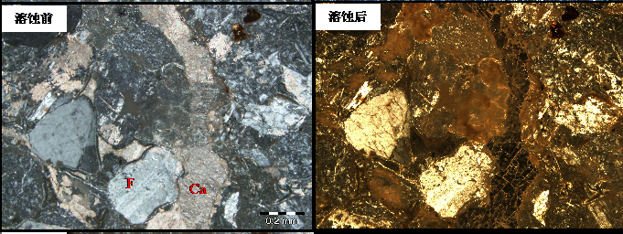
Numbering Figures,Arial, 9-Point Type, 1.25-spaced, Centered
Before
After
Fig.1 The comparision of before and after dissolution about tuffaceous sandstone
(Bei 28, 1531.2m, +, ×4; Ca-Calcite, F-Feldspar)

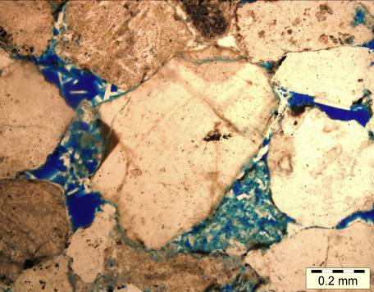  Before（-） | 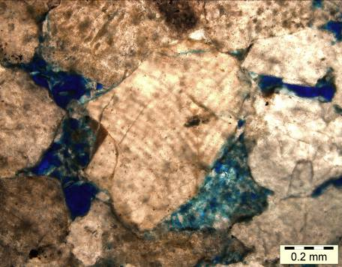  After（-）
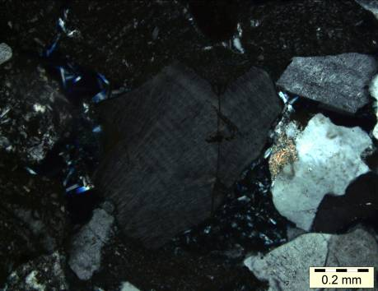  Before（+） | 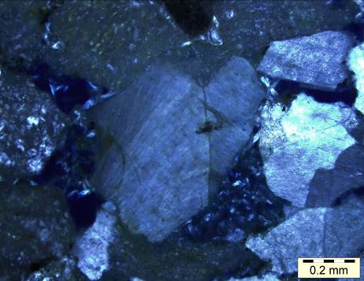  After（+）
Fig.2 The comparision of before and after dissolution about microcline
(Bei 28, 1548.6m, ×10)

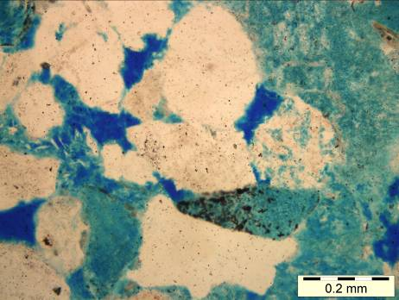  Before（-） | 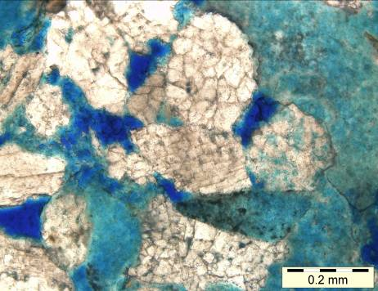  After（-）
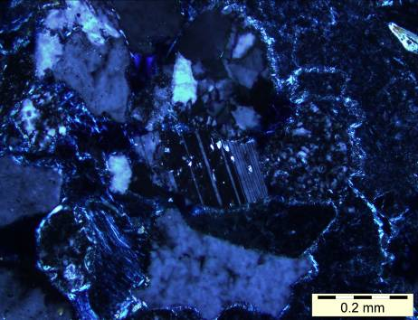  Before（+） | 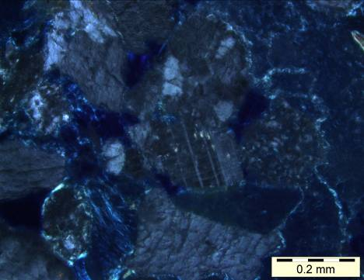  After（+）
Fig.3 The comparision of before and after dissolution about acid plagioclase
(Bei 28, 1495.8m, ×10)

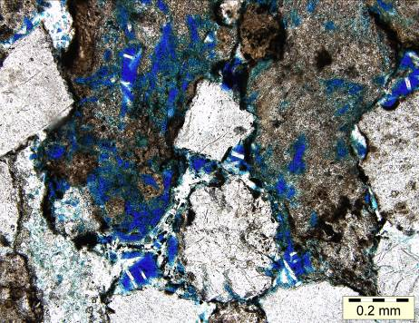  Before（-） | 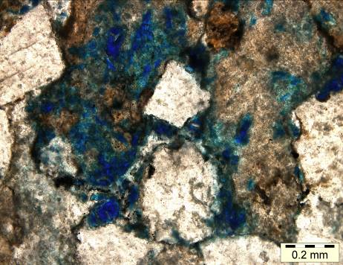  After（-）
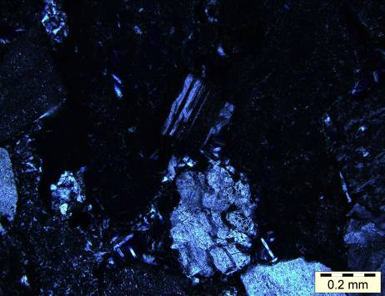  Before（+） | 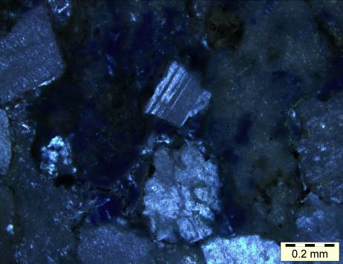  After（+）
Fig.4 The comparision of before and after dissolution about tuffaceous
(Bei 28, 1548.6m, +, ×10)
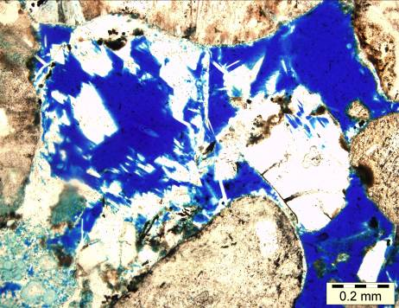  Before | 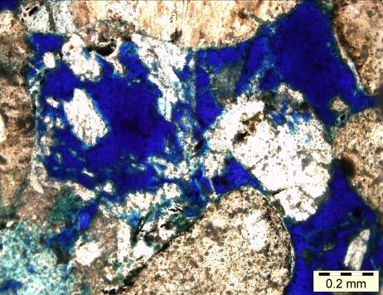  After
Fig.5 The comparision of before and after dissolution about intragranular dissolution pores
(Bei 28, 1548.6m, —, ×10)

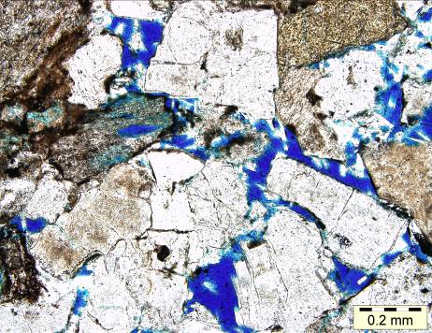  Before | 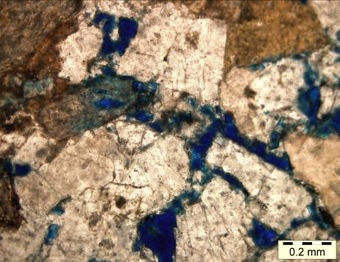  After
Fig.6 The comparision of before and after dissolution about interparticle dissolution pores
(Bei 28, 1548.6m, —, ×10)
Numbering Tables,Arial, 9-Point Type, 1.25-spaced, Centered
Tables
Table 1 Stratigraphic unit of Nanpu depression
Stratigraphic Unit |  |  | Stratigraphic Horizon | Code | Before Present  Time（Ma） | Time Interval  （Ma）
Cenozoic | Quaternary |  |  | Q | 2.0 | 2.0
Cenozoic | Neogene | Pliocene | Minghuazhen Formation | Nm | 9.0 | 7.0
Cenozoic | Neogene | Miocene | Guantao Formation | Ng | 23.3 | 14.3
Cenozoic | Paleogene | Oligocene | Dongying Formation | Ed₁ | 25.3 | 2.0
 |  |  |  | Ed₂ | 27.3 | 2.0
 |  |  |  | Ed₃ | 29.3 | 2.0
Cenozoic | Paleogene | Oligocene | Shahejie Formation | Es₁ | 35.4 | 6.1
 |  |  |  | Es₂ | 36.4 | 1.0
 |  |  |  | Es₃ | 42 | 5.6

About the authors
Liu Peipei, born in 1986, is a graduate student at the Northeast Petroleum University.
In 2010, She graduated from Northeast Petroleum University, resource exploration engineering, and got her Bachelor's degree. Now her research field is about the reservoir evaluation and prediction, and physical simulation of hydrocarbon migration.
E-mail: lpp1456@sina.com

Zhang Yunfeng, born in 1968, is a professor, Master's tutor at the Northeast Petroleum University.
In 1991, he graduated from Daqing Petroleum Institute, petroleum geology，and got his Bachelor's degree; In 1997, he graduated from Daqing Petroleum Institute, mineral resource prospecting and exploration, and got his Master's Degree; In 2004, he graduated from the Geology and Geophysics Institute of Chinese Academy of Sciences Institute, Mineralogy, Petrology and Mineral Deposits, and earned Doctor's Degree. Now his research field covers the reservoir evaluation and prediction, and physical simulation of hydrocarbon migration.
E-mail: yunfeng4510@163.com

